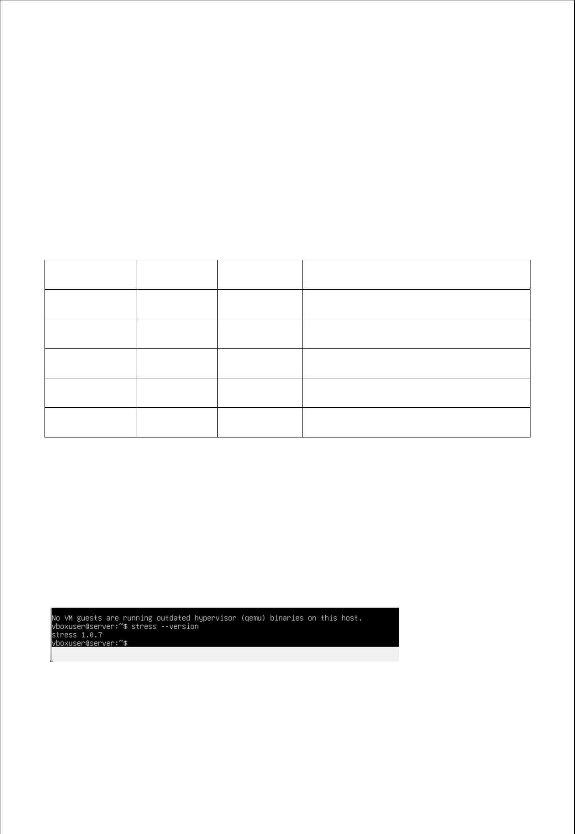
Week 3

Application Selection for performance Testing

Goal:

The goal of this week is to choose representative applications in order to assess various forms of system workload.

Application Selection Matrix:

Workload | Application | Status | Justification
Type
CPU-intensive | stress-ng | Selected | Generates configurable CPU load for
 |  |  | performance testing
Memory- | stress-ng | Selected | Simulates memory pressure
intensive | (vm)
I/O-intensive | fio | Installed & | Measures disk read/write performance
 |  | tested
Network- | iperf3 | Installed & | Evaluates network throughput
intensive |  | tested
Server | Apache2 | Selected | Represents real-world server behavior
workload

Evidence of Performance Testing:

To assess disc I/O performance, the fio tool was installed and run.

Network throughput between the workstation and server was measured using the installed iperf3 tool.

Fabian Gill A00017906

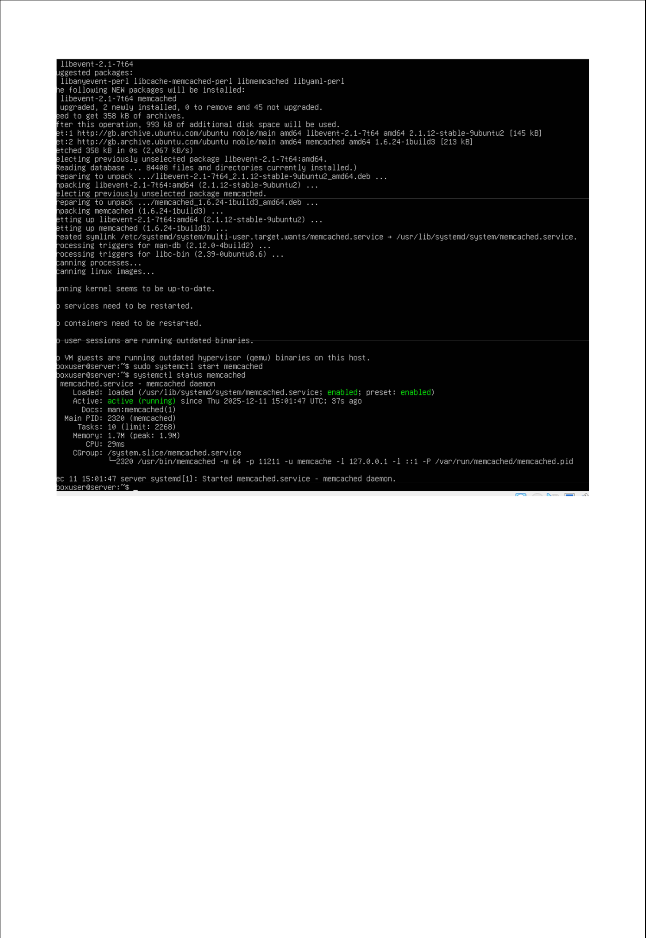

Fabian Gill | A00017906
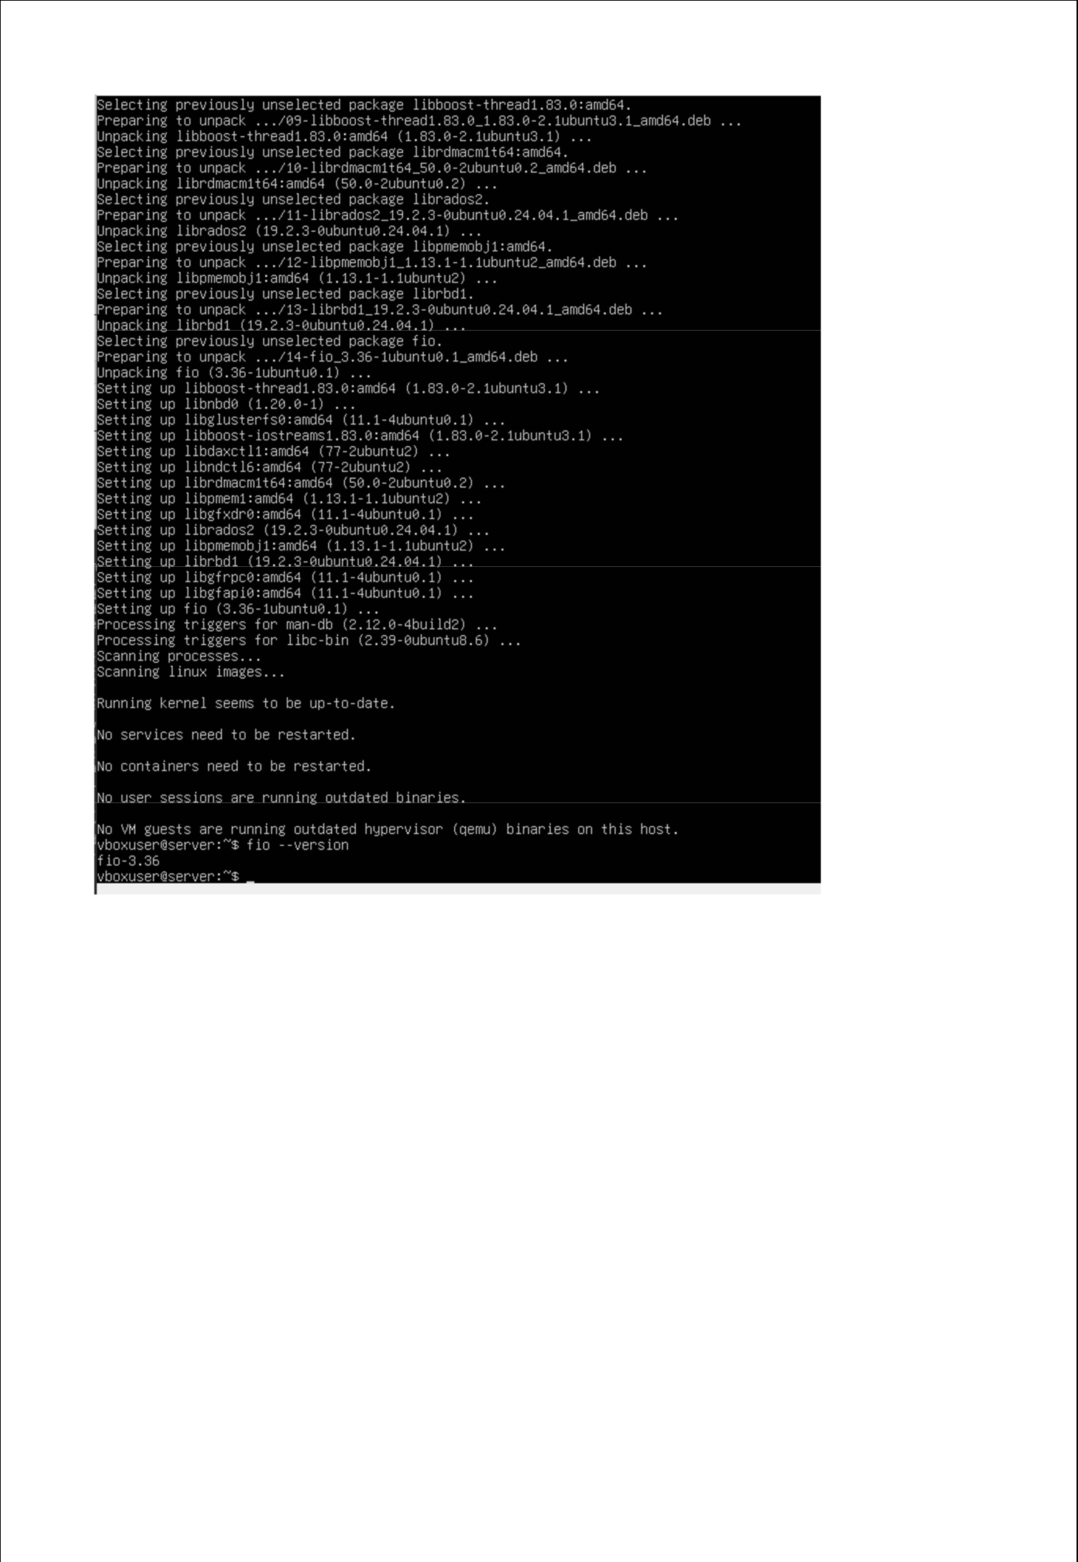

Fabian Gill | A00017906
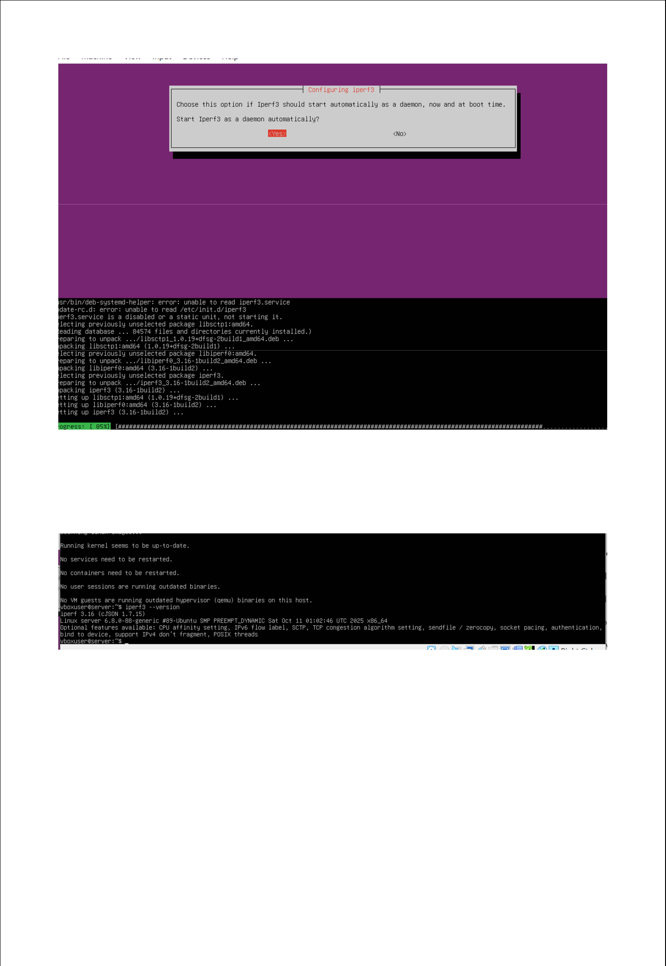

Fabian Gill | A00017906
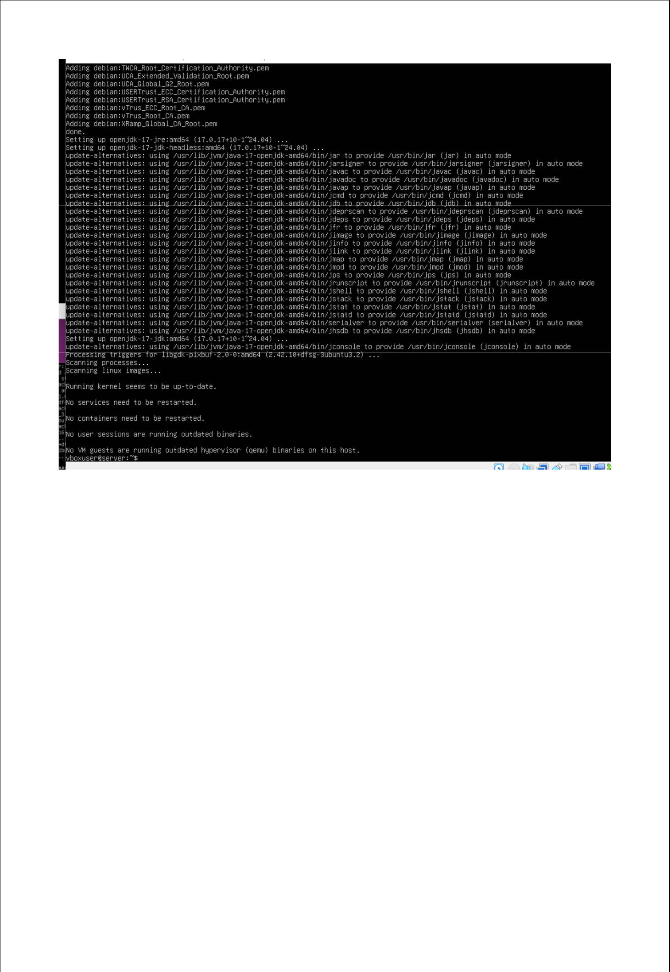

Fabian Gill | A00017906

